Homework #1

# Complete Tutorial 1: Getting Started with HTML5

**INITIAL DUE DATE: Sat Sept 23 9pm.** Submit what you have completed so far**.**

**FINAL DUE DATE: Mon Oct 2 11:59pm.** Submit the final work.

Instructions for various textbook version:

In the physical book and some eBooks, read **Tutorial 1 (pp1-70).** As you read complete all the steps in the **brown boxes** (or **black-colored steps** in some eBooks).

In the MindTap eBook and some eBooks, read **Tutorial 1** which consists of section numbers instead of page numbers. Read **sections 1-1 through 1-22**. As you read, complete all the **orange‑colored steps**. The first step you actually complete at the computer comes quite a few pages into the chapter. Refer to the pictures at the bottom of this document to see what the pages look like in MindTap.

Further take note, in some e-book versions of our textbook, you can enter the page numbers into the box on the screen to go to that page directly. For example, enter HTML65 to go to page 65 and enter HTMLA3 to go to Appendix A, p3. As well you can use a Table of Contents to navigate.

And read this: Use Notepad, Komodo Edit or other editor of your choice. Use the files in the folder called data files/html01/tutorial, that is, the data files in the tutorial folder that are inside the html01 folder of the set of data files for this textbook. Before you start, it is a good idea to make a copy of the tutorial folder so that you have the original files just in case you need them. When done, rename its folder called tutorial to **tutorial1_yourlastname**. Be sure all given files and the modified ones are in the folder. Zip, and drop zip file into the **Tutorial 1 Drop Box** in Brightspace.

More details specific to the use of the MindTap eBook (and a mention of some other ebooks)

To access Tutorial 1 in MindTap, click on the e‑book section link called:

**Tutorial 1: Getting Started with HTML5**

Below it, click on the link called:

Tutorial 1 Read.

… See next page

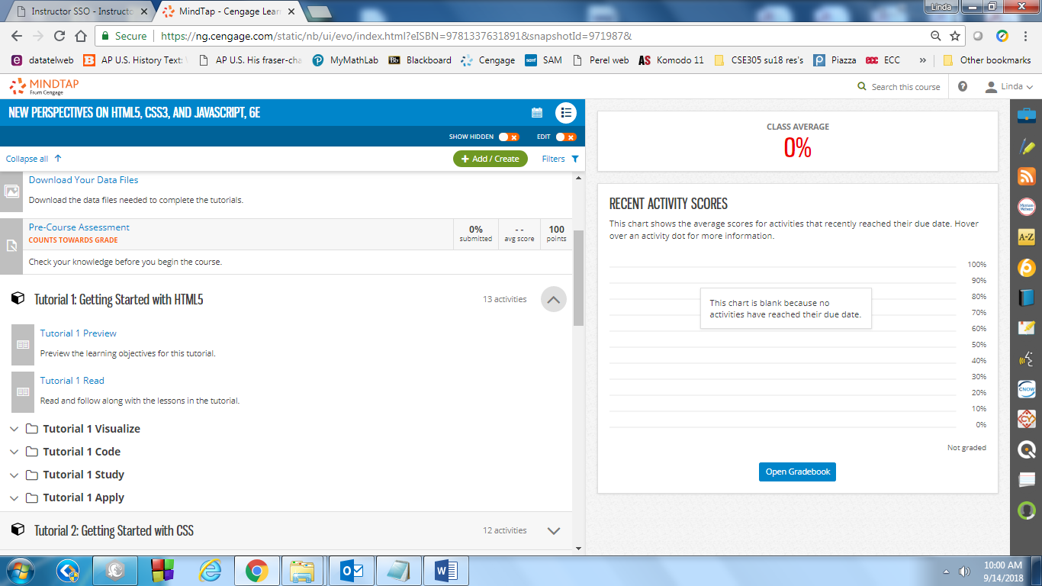

The steps you complete at the computer are indicated with orange-colored numbers as pictured below.(In some eBook versions they will be black-colored steps.)

Once you are in Tutorial 1 in MindTap you will see a link in the top left corner that gets you back to a chapter “Table of [Contents](javascript://)”. Use this link to jump around the chapter, or use the previous and next page arrows. To leave the chapter, click the X in the top right corner.